HARVEY NORTHCOTT MEMORIAL SCHOLARSHIP

APPLICATION PACKAGE
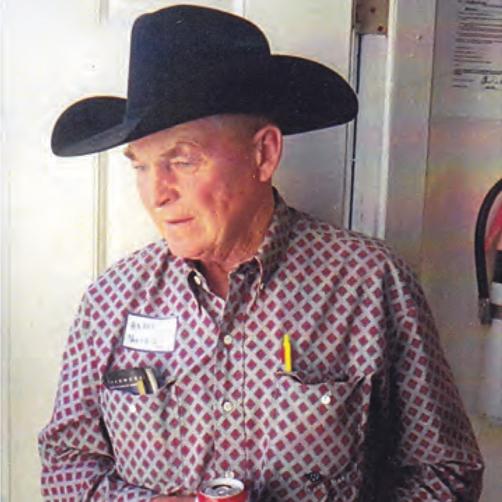

Funded by the
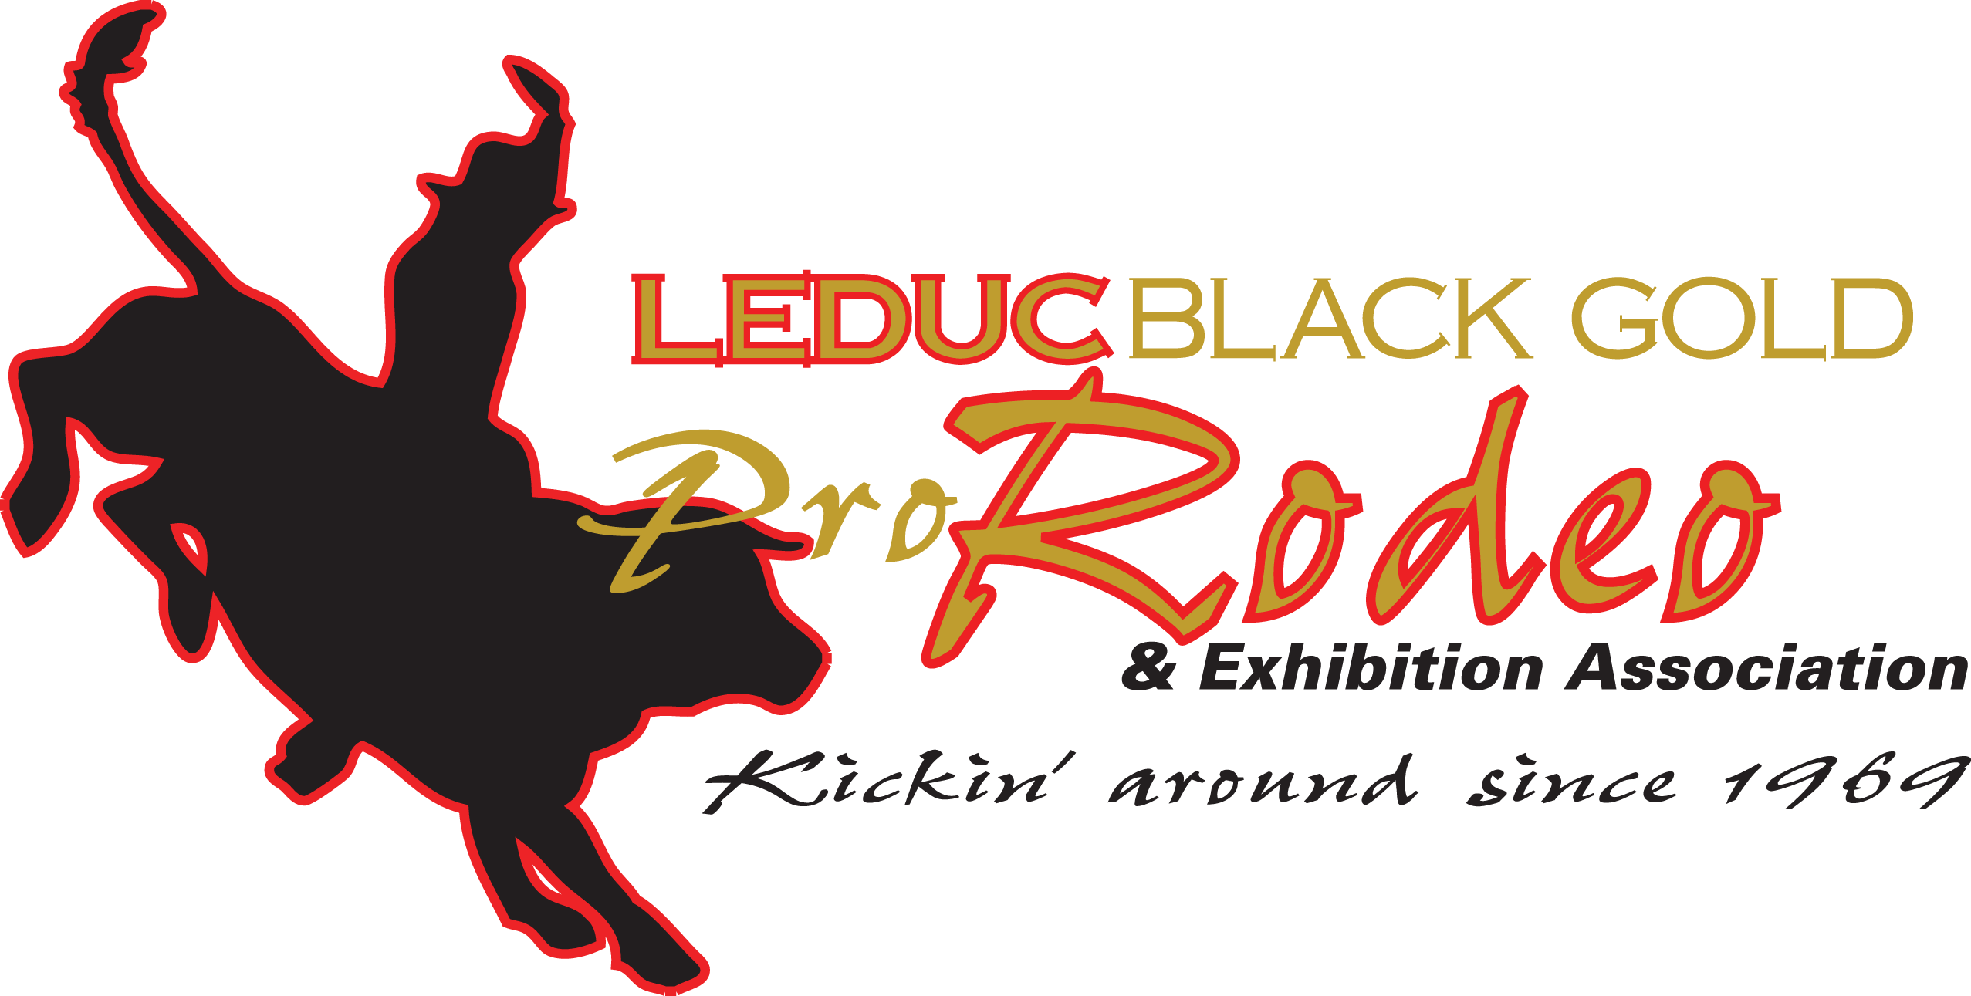

Applications must be postmarked by April 15 to be eligible for the current year and sent to:
Leduc Black Gold Pro Rodeo & Exhibition Association
Attention: Scholarship Committee
Box 3235
Leduc, AB T9E 6L9
HARVEY NORTHCOTT MEMORIAL FUND SCHOLARSHIP

A. Our Rationale and Philosophy:
Scholarships funded by the Leduc Black Gold Pro Rodeo & Exhibition Association in memory of Mr. Harvey Northcott are based on the following rationale and philosophy:
It is the mission of the Leduc Black Gold Pro Rodeo & Exhibition Association to promote, support and encourage agricultural opportunities in our urban and rural community.

We believe:
- Youth are the future of our community, country and industry.
- The education of students is a shared responsibility among the home, school and community. It is our responsibility to be a community leader that promotes agriculture.
- All students have a right to a sound education that will enable them to apply their learned skills to daily life.
- By supporting those who wish to pursue Agricultural related studies, we are assisting in the continuation of Agriculture in our community, our province and our country.

B. Scholarship Program Details:
- Two or three $1,000 scholarships will be awarded per year.
- The criteria for eligibility for the scholarships will be set by the Board of Directors of the Leduc Black Gold Pro Rodeo & Exhibition Association.
- The Scholarship Committee will made up of three representatives, including at least one board member and one other member of the association. The committee will review the applications and choose that years recipients.
- Recipients will be notified, and be requested to attend one of our rodeo performances to be recognized and receive their scholarship.

C. Scholarship Eligibility:
- These scholarships are open to students who reside in the County of Leduc or who are resident Albertans and are members of either an amateur or professional Rodeo Association.
- Applicants must have a Grade 12 Diploma and be entering or continuing as a full time student in one of the following types of program:
  - An Apprenticeship program
  - A Trades program
  - A post-secondary institution, college or university program.
Note that preference will be given to applicants entering programs which support and benefit the agricultural industry.
- Those interested in applying should note that their application must:
  - Be completed using this application form.
  - Be typed.
  - Be complete (ensure that all the information is accurate and correct. Only complete applications will be considered).
  - Include an original photo.
  - Include a copy of your official transcript request (inclusive of the date requested).
  - Be submitted (please send the original copy) by mail to the Leduc Black Gold Pro Rodeo & Exhibition Association at the address shown above. Applications must be postmarked by April 15 to be eligible for the current year.

**Notes:
- All recipients are required to provide a confirmation of enrolment and payment of tuition from their institution and their Social Insurance Number in order for the funds to be released. Failure to do so will result in the scholarship being awarded to the next eligible candidate.
- Scholarship funds will be released after July 31.
- Recipients who do not finish the first semester of their program will forfeit the scholarship.
- Do not leave sections blank, if you are unsure of information make sure it is correct prior to submitting your application. Only information submitted can be used.
Application Checklist:

 | Information About Yourself |  | References
 | Record of Involvement in Agriculture |  | Photo
 | Record of Involvement in Community |  | Scholarship Applicant Promise
 | Information About Your Studies |  | Signatures where necessary
 | Written Essay/Interview Question |  | Transcript Request

D. Harvey Northcott Memorial Scholarship Application Form:
Proofread and edit your application. Your application must be TYPED and COMPLETE. Please use the space provided; do not alter or write in the gray areas of the document. Be sure to save your document as you proceed. When you have completed all the required information print a copy and mail it to the above indicated address.

1. Information About Yourself
Last Name
First Name
Home Address
Town/City, Province
Postal Code
Phone Number
Email address

2. Record of Involvement in Agriculture and/or the Sport of Rodeo:
What organizations are or were you a member of? (Start with the most recent, additional space can be added if needed). Please provide the full name of the organization.
Name of Organization | Position Held  (i.e., President, Secretary, Committee Chair, etc.) | Year(s)  (e.g. 1998-2005)

3. Record of Involvement in the Community:
a) List activities/events for which you volunteered to help improve your community:
(No more than 7 significant activities should be listed)

Activity/Event (e.g., Volunteer at the local hospital,) | Year(s)

b) List activities/events that you have played a leadership role in and had to use your communication skills:
(No more than 7 significant activities should be listed).

Activity (e.g. Emcee at a school or community assembly) | Year(s)

c) List any awards you have received within the last three years:
(No more than 7 significant awards should be listed)

Award (e.g. Academic, Community, Sports) | Sponsor | Year

4. Information about your current/future studies (see note below):
What post-secondary institution do you plan to attend?
Location (City/Province):

What type of program are you enrolled? (check one) | ____ Certificate/Diploma  ____ Degree
Name of the Degree/Diploma:

Name of the Program:

Please provide a brief description of the program:
(no more than 150 words)

Please provide a brief description of your career plans:
(no more than 100 words)

**NOTE: Please do not use abbreviations. Check your post-secondary calendar for the proper name of the degree and program in which you are enrolled for the upcoming year.
Example: if you are enrolled in general sciences but intend to go on and study veterinarian medicine, enter Bachelor of Science as the degree and list Veterinarian Medicine as the program.

5. Essay:
Please provide your answer to the written interview by attaching (to your application) a typewritten answer to the following question. The answer should be a minimum of 300 words, but no more than 500. Please be clear, concise and innovative in your response. Remember to proofread and include your full name on the essay.
“How will your completion of the program you are currently in/applying for benefit agriculture and/or the sport of rodeo and your community in the future?”
6. References:

You are required to provide two references (one each from the following types) and their contact information. As references may be phoned, they should be notified that you have listed them as a reference. Applicants with missing references will not be considered.

Type | Name of reference person: | Phone number and Email address of reference:
School: |  | Phone:  Email:
Community: |  | Phone:  Email:

Please Note: Relatives cannot be used as references.
7. Photo:

Please attach a wallet size (2” x 3”) photo of yourself with your application. This photo must be suitable for publication in our annual rodeo program. A school grad photo is ideal. Photocopies or scanned photos are not acceptable. Do not crop the photo. Note that the photo will not be returned to you.

8. Have you ever been charged or convicted of a Criminal Offence?
□ YES □ NO

NOTE: Successful candidate(s) may be required to provide an acceptable current Criminal Records Check prior to release of funds.

9. Scholarship Applicant Promise:

As a scholarship recipient I promise to complete the full fall and winter terms of the post-secondary institution that I enroll in. If I do not complete the required terms, I will return all scholarship money to the Leduc Black Gold Pro Rodeo & Exhibition Association from whom I received it. I will provide the Leduc Black Gold Pro Rodeo & Exhibition Association with a confirmation of enrollment and payment of tuition, and Social Insurance Number as requested. If I fail to do so, the scholarship will be awarded to another applicant.
I understand the above conditions and I declare that the information in this application form is correct. If I am granted a scholarship, I will comply with all its terms. I also agree to allow my picture and information contained in this application to be used for promotion of the scholarship program.
Signature of applicant _________________________________ Date______________
Note: if applicant is under 18, a parent or a guardian must also sign the application.
I declare the information is correct to the best of my knowledge and agree to all rules of the scholarship program.
Signature of parent or guardian __________________________ Date______________

10. Transcript Request:
Contact Alberta Learning and request a transcript to be sent to the Leduc Black Gold Pro Rodeo & Exhibition Association. Send the request form and your payment to Alberta Learning by April 15. REQUEST YOUR FINAL HIGH SCHOOL MARKS. Do not send the original request form to the Leduc Black Gold Pro Rodeo & Exhibition Association, but include a photocopy with your application. Without a transcript, your application will not be considered.

Alberta Learning Contact information Office and mailing address:

Transcripts Unit, Alberta Education
2nd Floor 44 Capital Boulevard
10044-108 St
Edmonton, AB T5J 5E6
www.education.gov.ab.ca
Phone: 310-0000 (780) 427-5318 Fax: (780) 422-2137

